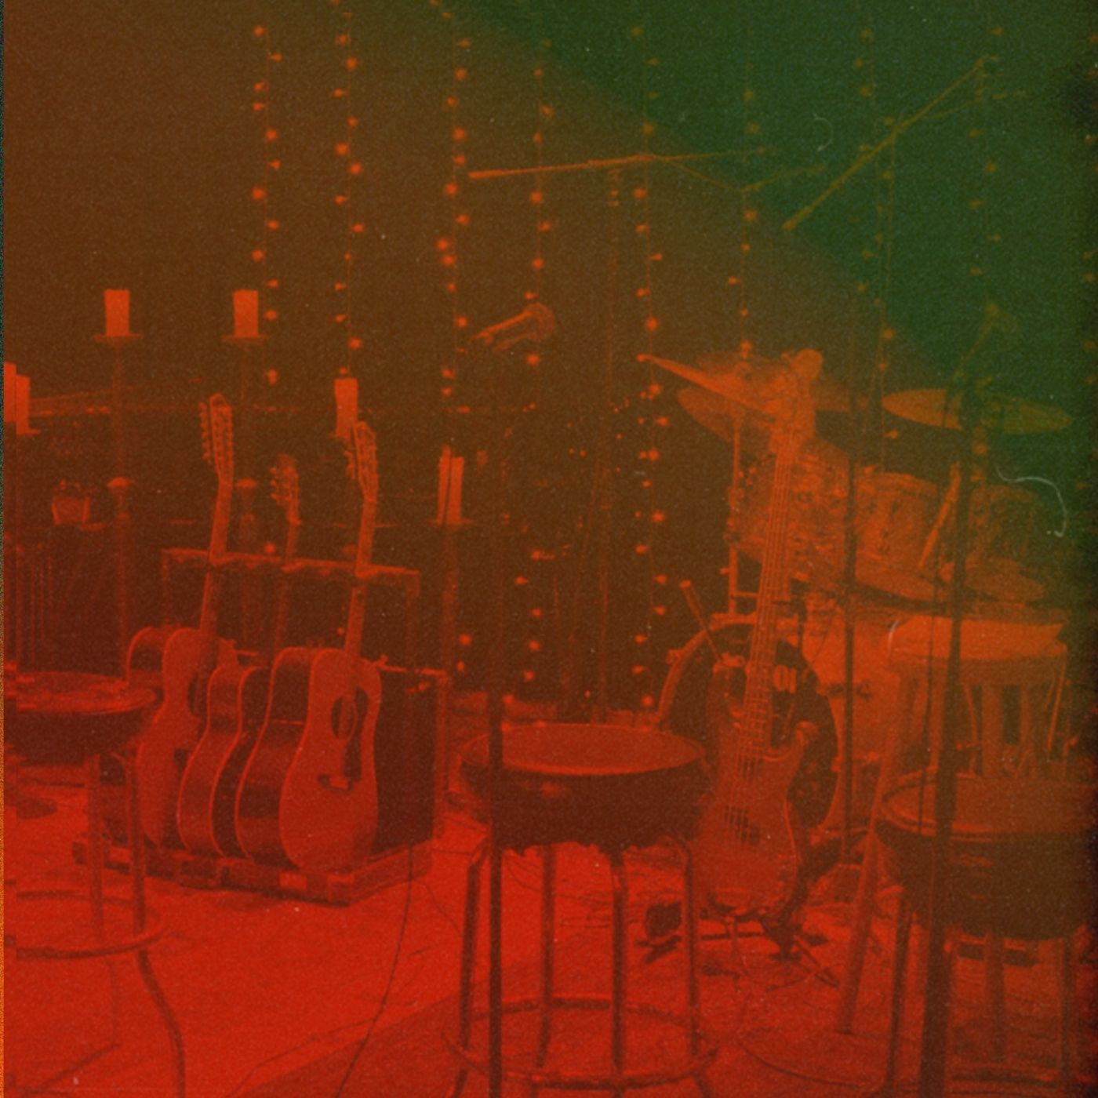
What Coulda Been
Music and Lyrics by Russ Soper

I see your smile of all you hold dear
Through borrowed eyes, all becomes clear
Looking back, as you long for yesterday
The marks of time will seldom wash away

You can't see .. your ever-slow demise
Until it hits.. right between the eyes

Rise up, never wait for a knock on your door
Time moves on past all you live for
All on you, salvation from within
I will never say .. what could've been

When darkness gives way to the dawn
My wayward child, you must ramble on
I was blind to you somehow
But I am so done with that now

You can't see .. your ever-slow demise
Until it hits.. right between the eyes

Rise up, never wait for a knock on your door
Time moves on past all you live for
All on you, salvation from within
I will never say .. what could've been

Rise up, never wait for a knock on your door
Time moves on past all you live for
All on you, salvation from within
I will never say .. what could've been (Repeat)

Who’s Sorry Now
Music and Lyrics by Russ Soper

Twist the tale to suit yourself, nothing left to see
Can't you see it clear my dear what'll be, will be
Maybe someday
You'll know what you mean to me

Time after time... lord knows how
It all seems to make sense ... to you somehow
So please tell me
Just who's sorry now?

Left empty handed, never so ideal
Until I see that none of this, none of this is real
So finally
I grab hold of the wheel

Time after time... lord knows how
It all seems to make sense ... to you somehow
So please tell me
Just who's sorry now?

I guess that's all for now, until another day
And I wouldn't have it any other way
It's goodbye
No matter what you say

Time after time... lord knows how
It all seems to make sense ... to you somehow
So please tell me
Just who's sorry now? (Repeat)

Dirty Little Secrets
Music and Lyrics by Russ Soper

Hey Hey, Hey Hey, Hey Hey

Always played the martyr, heart on your sleeve
It's written all over your face, you know what I mean
Is it any wonder? Not hard to see
You've got a little secret, one you just can't keep

Hey.. dirty little secrets in your head
Dirty Little Secrets
Hey... .. just a little respite now instead
Dirty Little Secret

Such a height to fall, when perched so high
A little bit of truth now, would be just fine
Yours is the silence, of consent
Such a fantastic story, such a terrible debt

Hey.. dirty little secrets in your head
Dirty Little Secrets
Hey... .. just a little respite now instead
Dirty Little Secret

What I've been looking for, was remiss
30 coins of silver for the, Judas kiss
You get what you want, with that cheshire grin
I swear it's a dream but, it's everything you've ever been

Hey.. dirty little secrets in your head
Dirty Little Secrets
Hey... .. just a little respite now instead
Dirty Little Secret

Black Soul River
Music and Lyrics by Russ Soper

Come on down to Black Soul River where the water runs so deep
Cleanse my heart in the midnight sun, the Lord my soul to keep
Lord have mercy, cast away my sins
Water rain upon my head, free of Satan’s grip (Satan’s grip)

Commitments of salvation, free of all black deeds
Redemption is at hand, and I shall be received
Rise on up; the truth will set you free
All this can be yours, all for one small fee
So gather round!

Wipe the tears upon your face; raise your hands up high
The faithful drop down to their knees; release a subtle cry
Blood boils over under pale moonlight
Black water purge the pain away; everything’s gonna be all right

Come on down to Black Soul River where the water runs so deep
Cleanse my heart in the midnight sun, the Lord my soul to keep
Lord have mercy, cast away my sins
Water rain upon my head, free of Satan’s grip (Satan’s grip)

Shine on, Shine on. My eyes can finally see
Empty words and sleight of hand—pure hypocrisy
A mouthful of sermons, and a pocketful of lies
No one more deserving of 25 to life

Come on down to Black Soul River where the water runs so deep
Cleanse my heart in the midnight sun, the Lord my soul to keep
Lord have mercy, cast away my sins
Water rain upon my head, free of Satan’s grip (Satan’s grip)

Join your hands. The sun will never shine
The mirror shows a different face; you think yourself divine
The lies you spread as truths you do bestow
In times of trouble we find what truly lies below
Oh yeah…oh yeah….Hallelujah…hallelujah!

Come on down to Black Soul River where the water runs so deep
Cleanse my heart in the midnight sun, the Lord my soul to keep
Lord have mercy, cast away my sins
Water rain upon my head, free of Satan’s grip (Satan’s grip)

Tell Me
Music and Lyrics by Russ Soper

Something about you, I could not deny
Just a little bit of danger, perfection in my eyes
Everytime I lay my head, a vision of you I see
Trouble for sure, but I just couldn’t let it be

She’s so beautifully broken
As I make the same mistake again

Nothing good is easy, time will tell my dear
To pursue promise of beauty with no peer
Center of attention, not an eye can ever stray
Seems you craved the spotlight long before today

She’s so beautifully broken
As I make the same mistake again

Tell me the words I longed to hear
Pour me the sweetest tonic that is you my dear
Show me the lies are not what they might seem
Tell me the sweetest words you never ever mean
Now I finally see what I couldn’t before
As you glide atop the water with a crown of thorns
I wanted so much more than just a little taste
It’s not the catch, but the thrill of the chase

She’s so beautifully broken
As I make the same mistake again

Tell me the words I longed to hear
Pour me the sweetest tonic that is you my dear
Show me the lies are not what they might seem
Tell me the sweetest words you never ever mean (Repeat)
Do As You Please
Music and Lyrics by Russ Soper

I may not have what you want, but I got all that you need
I’ll be your bad-ass mother get you down on your knees

You ramble on about the good that you’ve done
I can’t hear a word through your cocaine tongue
You break free of the shackles of the time that binds
Straight from the corner of my wandering eye

I may not have what you want, but I got all that you need
I’ll be your bad-ass mother get you down on your knees
I’ll give you all that I got, so tell me do you believe?
I’ll say it once more baby do as you please

The time has come to start your life anew
Casting a shroud over all that was true
Forever lost in your dreams, they never made my bed
Sometimes things are better left unsaid

I may not have what you want, but I got all that you need
I’ll be your bad-ass mother get you down on your knees
I’ll give you all that I got, so tell me do you believe?
I’ll say it once more baby do as you please

So good to see how you moved on with ease
Happy to be free and now rid of your disease
Soon will come the day I don’t remember your name
I am the fire not just another flame

I may not have what you want, but I got all that you need
I’ll be your bad-ass mother get you down on your knees
I’ll give you all that I got, so tell me do you believe?
I’ll say it once more baby do as you please (Repeat)

Sweet Serenade
Music and Lyrics by Russ Soper

She tells tales, I long to believe
Where halos cease to glisten
With hollow eyes, of deceit
A tale of her own volition

Blinds are drawn, door is closed
A symptom of deeper malaise
And now everything’s all right
As the view fades from upon her gaze

My sweet serenade
I see what was lost, still remains
I’ll hold you as you leave
and see you forever in my dreams

She longs to feel, to feel the warmth
The warmth of other suns
Somewhere, on the path it seems
It’s all just come undone

My sweet serenade
I see what was lost, still remains
I’ll hold you as you leave
and see you forever in my dreams

A spot is chosen
When solace won’t suffice
A pinch to keep the wolf from the door
A smile, as darkness overtakes the light

Memories, refuse to fade
I’ve not made amends
Addiction’s, but a banquet to
… to the bitter end
My sweet serenade
I see what was lost, still remains
I’ll hold you as you leave
and see you forever in my dreams

She tells tales, I long to believe

24 Karat Lunacy
Music and Lyrics by Russ Soper

When we met you were always smiles and happy
Then I began to see things slowly, then it happened so abruptly
The changes were oh so clear. What happened to you my dear?
I no longer recognize, much to my surprise

Vampire sucking life from everyone around
Like a child on the edge of a meltdown

Time it always short, to spend it with a nutter, now that I can finally see
Manufactured drama, dissin' on your mama, taking little bits of me
Never ever happy, always being tacky, why can't you just let me be
Now I'm full of bliss and I don't seem to miss, your 24 Karat lunacy

Constant calls and showing up from nowhere
If only I had known I do swear, to others I will warn to beware
Now I can't get rid of you, my stalker what I can do
To ease your anxiety, certifiably

Vampire sucking life from everyone around
Like a child on the edge of a meltdown

Time it always short, to spend it with a nutter, now that I can finally see
Manufactured drama, dissin' on your mama, taking little bits of me
Never ever happy, always being tacky, why can't you just let me be
Now I'm full of bliss and I don't seem to miss, your 24 Karat lunacy (Repeat)

Until I See You Again
Music and Lyrics by Russ Soper

Yesterday, a call I'd not expect
Yesterday, I recall the day we first met
Before today, you fought for so.. so, very long
Just today, I can't believe that you are gone

I don’t know where to begin
Such a first class fool I've been

Until I see you again
Until I see you again
Until I see you again

There will come a time
When birds no longer sing and the words just won't rhyme
Yes there will come a time
I'd swear it's a dream, but my eyes are open wide

I don’t know where to begin
Such a first class fool I've been

Until I see you again
Until I see you again
Until I see you again (Repeat 2x)

New Day’s Sun
Music and Lyrics by Russ Soper and Hans Walters

Those family values, well, they don’t mean shit to me
The good ol’ days” just really weren’t all that
Clean livin’ just ain’t all that it’s cracked up to be
I mean to put us back on track.

Come on down to my place honey
Don’t need drugs and I don’t need money
What I want and what I need is you.
Ride your bike or take your car
Drive it fast but not too far
What I want and what I need is you.

Stay all night
Till the morning comes.
You can leave by dawn and then you’ll
Greet the new day’s sun.

Ain’t no God in Heaven and there ain’t no room in Hell
And so we’re livin’ day by day
I can’t be trusted and I can’t be satisfied
Unless we push the limits all the way

What’s done is done so waste not living in the past
Don’t worry ‘bout the future come what may
So baby, baby baby let’s just leave it all in dust
While we own the night and seize the day

Stay all night
Till the morning comes.
You can leave by dawn and then you’ll
Greet the new day’s sun.

No Regret
Music and Lyrics by Russ Soper

Anytime you want to view my etiquette
Yea your silver tongue and steely gaze is all I get
Sold your soul for just one night to those you do adore
While I blindly follow you for just a lil' while more

Always looking around
Something shiny new for everyday
Tales they do astound
Everybody else you cast way

Cuz you can't save everybody all of the time - all the time
It's what you get, no regret for such a crime - such a crime

Every word you say is backed by violins
A never-ending theater, a master of spin
Yes, you long to be the darling of society
A very common tale, sweetie can't you see?

Always looking around
Something shiny new for everyday
Tales they do astound
Everybody else you cast way

Cuz you can't save everybody all of the time - all the time
It's what you get, no regret for such a crime - such a crime

All the wasted time with those that you call friends
Yes, a little bit of hell on heels where parties don't end
You swear you'll get your shit together, back on track
Keep on dreamin' baby cause it's never coming back

Cuz you can't save everybody all of the time - all the time
It's what you get, no regret for such a crime - such a crime (Repeat)

(Still I’m ) Coming Home
Music and Lyrics by Russ Soper and Hans Walters

When I look back on the days of my wasted youth
What they told us was an outright lie
Or at best it was just half the truth
It’s no excuse if you don’t try.

Wish I knew now what I thought I knew way back when
Then again sometimes I no longer care
Some days I just wanna crawl out of my skin,
And let ‘em all in to strip me bare.

And when all is said and done
We need the rise after the fall
Spent too much time out in the sun
And lost it all…

Out on the edge again
But Still I’m coming home
Out on the edge again
But Still I’m coming home

Please tread softly, ‘cause I’m worn down to the bone
Break my body just to feed my soul
No win or losin’ and I can’t do this alone
Fighting my way in from the cold.

And when all is said and done
We need the rise after the fall
Spent too much time out in the sun
And lost it all…

Out on the edge again
But Still I’m coming home
Out on the edge again
But Still I’m coming home
From so far away I see so much clearer now
Gotta feelin’ for what this is about
It ain’t easy keepin’ pace with my worried mind
Got to hope we can work it out.

Out on the edge again
But Still I’m coming home
Out on the edge again
But Still I’m coming home

Still I’m Coming Home
Still I’m Coming Home
Still I’m Coming Home
Still I’m Coming Home

Out on the edge again
But Still I’m coming home
Out on the edge again
But Still I’m coming home

Hazel Gaze
Hanz: Vocals
Russ Soper: Guitars, Backing Vocals
Konrad Payne: Bass
Mary Jo Verruto: Piano, Backing Vocals
Spiros Arnakis: Drums
Molly Klein: Backing Vocals, Hand Percussion
Nicole Riolo: Backing Vocals, Hand Percussion

Additional Musicians
Anna Nordmoe: Violin
Jennifer Axelson: Violin
Mirandi Hostetter: Viola
Rachel Gawell-Burns: Cello

Production
Recording / Mixing Engineer: Daniel Alba
Mastering Engineer: Oscar Zambrano

